🌍 A Comprehensive Measure of Well-Being

(HDI Prediction System)

Machine Learning Powered Human Development Index Prediction Platform

Authors:
Paruchuri Venkatesh Rokkam Guna Sekhar

Table of Contents
- Executive Summary
- Project Overview
- Problem Statement
- Proposed Solution
- System Features
- Application Screens Overview
- Machine Learning Workflow
- Dataset Description
- Technology Stack
- System Architecture
- Application Workflow
- Demo Screenshots
- Security Features
- Advantages
- Business & Global Applications
- Future Enhancements
- Results & Achievements
- Conclusion
- Project Authors
- References & Resources

Executive Summary
The Human Development Index (HDI) Prediction System is a Machine Learning-powered web application designed to estimate the Human Development Index of a country using important socio-economic indicators. The Human Development Index is one of the most widely accepted measures of national development because it evaluates multiple dimensions of well-being rather than focusing solely on economic growth. These dimensions include health, education, and standard of living, making HDI a comprehensive indicator of human progress.

This project combines Machine Learning, Data Analytics, and Full-Stack Web Development to create an intelligent prediction platform capable of producing accurate HDI scores in real time. The application has been developed using Python, Flask, Scikit-Learn, SQLite, and Bootstrap, providing a modern, secure, and responsive web interface for users.
Unlike traditional HDI calculation methods, which rely on manually collected reports and historical datasets, this application automates the prediction process using a trained Machine Learning model. By entering a country's key development indicators, users instantly receive an estimated HDI score along with its development category (Low, Medium, High, or Very High).
The system is designed for a wide range of users including students, researchers, government agencies, NGOs, policy analysts, economists, and international organizations. It supports data-driven decision-making by providing quick predictions, interactive dashboards, and historical analysis. Overall, the project demonstrates how Artificial Intelligence and Machine Learning can simplify complex socio-economic analysis while making development assessment faster, more accurate, and more accessible.

Project Overview Purpose
The primary purpose of this project is to develop an intelligent web application capable of predicting the Human Development Index (HDI) of countries using Machine Learning techniques. Instead of relying on manual calculations and historical reports, the system provides real-time predictions based on essential development indicators.

Objectives
The major objectives of the project are:

- Develop an accurate Machine Learning model capable of predicting HDI scores.
- Categorize countries into four internationally recognized development levels.
- Build a secure and user-friendly web application.
- Store prediction records for future reference and analysis.
- Provide analytical dashboards for better understanding of prediction trends.
- Demonstrate an end-to-end Machine Learning deployment using Flask.

Importance
Traditional methods of evaluating HDI often involve collecting data from multiple international organizations over several years. This process is slow, resource-intensive, and unsuitable for rapid policy decisions.
This project addresses these limitations by providing:

- Instant prediction results
- Automated data analysis
- Reduced manual effort
- Better decision-making support
- Interactive visualization of development trends

The system represents a practical implementation of Machine Learning for solving real-world socio-economic problems.

Problem Statement
The Human Development Index is one of the most important indicators used by governments and international organizations to evaluate the quality of life in different countries. However, conventional HDI assessment depends heavily on official reports published periodically by organizations such as the United Nations Development Programme (UNDP). This introduces delays in obtaining updated development information.
Several challenges exist in the traditional approach:

  - Manual collection of socio-economic statistics from multiple sources.
  - Time-consuming data verification and analysis.
  - Delayed publication of development reports.
  - High dependency on historical data.
  - Limited capability for rapid forecasting.
  - Increased possibility of human error during calculations.

Because of these limitations, governments and researchers often lack immediate insights into changing development conditions.
The project addresses these issues by introducing an AI-powered prediction system that performs automated analysis using Machine Learning algorithms. The system enables faster assessments, supports evidence-based policy planning, and reduces dependence on manual calculations.

Proposed Solution
The proposed solution is an intelligent Human Development Index Prediction System that integrates Machine Learning with a Flask-based web application.
The Machine Learning component is responsible for learning relationships between socio-economic indicators and HDI values. A trained Linear Regression model processes the input data and generates accurate HDI predictions within milliseconds.
The application consists of several integrated modules:

Machine Learning Engine

- Data preprocessing
- Feature scaling
- Model training
- Model evaluation
- Prediction generation
- Model serialization using Pickle

Flask Web Application
The web application provides a modern interface where users can securely register, log in, submit country information, and receive prediction results instantly.

Database Management
SQLite stores user accounts, prediction history, and application records using SQLAlchemy ORM.

Interactive Dashboard
The dashboard summarizes prediction statistics through visual charts, average HDI scores, prediction counts, and recent activities.

System Features
The application offers several advanced features designed to improve usability, performance, and user experience.
🔐Secure User Authentication
Users can register, log in, and securely access the application using Flask-Login. Passwords are encrypted before storage, ensuring account security.
🤖Machine Learning Prediction
The system predicts HDI scores using a trained Linear Regression model. Predictions are generated in real time based on user-provided development indicators.
📊Interactive Dashboard
The dashboard displays important analytical information including:

- Total Predictions
- Average HDI Score
- Active Machine Learning Model
- Prediction Distribution Chart
- Recent Prediction Activity
📝Prediction History

Every prediction is automatically stored in the SQLite database. Users can review previous predictions, inspect input indicators, and delete unnecessary records.
📈Data Visualization
Interactive charts help users understand development patterns and prediction distributions.
🎨Modern User Interface
The application follows a modern Glassmorphism-inspired design using Bootstrap, responsive layouts, and smooth animations for improved user experience.

✅Input Validation
Both client-side and server-side validation ensure that invalid or incomplete data cannot be submitted.

Application Screens Overview Home Page
The landing page serves as the introduction to the application. It features a modern hero section with gradient backgrounds, a concise project description, and a prominent "Start Prediction" button. Below the hero section, three informative feature cards explain the application's workflow:
  - Input Indicators
  - Machine Learning Analysis
  - Actionable Insights

This page provides users with a clear understanding of the application's purpose before they begin making predictions.

Prediction Page
The Prediction page is the core functionality of the system. It contains two main sections: The left panel includes an intuitive input form where users provide:
  - Country Name
  - Life Expectancy
  - Mean Years of Schooling
  - Expected Years of Schooling
  - Gross National Income per Capita

After submitting the form, the right panel immediately displays:

  - Predicted HDI Score
  - Development Category
  - Visual Result Card

This design allows users to view both input parameters and prediction results simultaneously.

Dashboard
The Dashboard provides a comprehensive overview of system activity and prediction analytics. It displays key performance indicators such as:
  - Total Predictions
  - Average HDI Score
  - Active Machine Learning Model
  - Prediction Distribution Doughnut Chart
  - Recent Activity Panel

These visual components help users analyze overall prediction trends and monitor system usage.

Prediction History
The Prediction History page stores all previously generated predictions in a structured table. Each record includes:
  - Country Name
  - Prediction Date
  - Input Indicators
  - HDI Score
  - Development Category

Users can inspect prediction details, manage historical records, and remove unwanted entries.

Machine Learning Workflow
Dataset → Data Cleaning → Feature Engineering → Train-Test Split → Feature Scaling → Model Training → Model Evaluation → Model Selection → Model Serialization → Flask Deployment → Prediction

Model Performance:
R² Score: 0.9393
RMSE: 0.0248
Algorithm: Linear Regression

Dataset Description

Input Features:

Feature Dimension | Target Metric Description | Valid Input / Example | Data Type
Country Name | Name of the country selected for HDI prediction. Used as the reference for regional analysis and prediction history. | Example: India, Japan, Canada | String
Life Expectancy (Years) | Represents the average number of years a person is expected to live. It reflects the country's overall healthcare quality and living conditions. | Example: 82.4 Years | Float
Mean Years of Schooling | Average number of completed years of education for adults aged 25 years and above. It measures the educational attainment of the population. | Example: 12.6 Years | Float
Expected Years of Schooling | Number of years of schooling that a child entering school is expected to receive throughout their education. It indicates future educational opportunities. | Example: 18.1 Years | Float
GNI per Capita (USD) | Gross National Income per person adjusted for purchasing power parity (PPP). It represents the average income and standard of living of a country's population. | Example: $66,494 | Float

Prediction Output:

Output Parameter | Description | Example
HDI Score | A predicted numerical Human Development Index value ranging from 0.000 to 1.000, generated by the Machine Learning model. | 0.879
Development Category | Classification of the country based on its predicted HDI score according to UNDP standards. | Low, Medium, High, Very High

Technology Stack
Frontend: HTML5, CSS3, Bootstrap, Jinja2 Backend: Python, Flask, Flask-Login Database: SQLite, SQLAlchemy
Machine Learning: Scikit-Learn, Pandas, NumPy
Model Storage: Pickle
Visualization: Matplotlib
Testing: PyTest, Virtual Environment

System Architecture
Presentation Layer: HTML5, Bootstrap, Jinja2, CSS3
Application Layer: Flask app factory, Blueprints, Session management Business Logic Layer: Authentication, Prediction, Validation, Analytics Machine Learning Layer: Preprocessing, Scaling, Model Prediction Data Access Layer: SQLAlchemy ORM, Database Models
Database Layer: SQLite
Utilities: Logging, Config, Model Serialization

Application Workflow
1. Register → 2. Login → 3. Dashboard → 4. Predict → 5. ML Model → 6. Result → 7. Save History → 8. Dashboard Update → 9. View History

Demo Screenshots
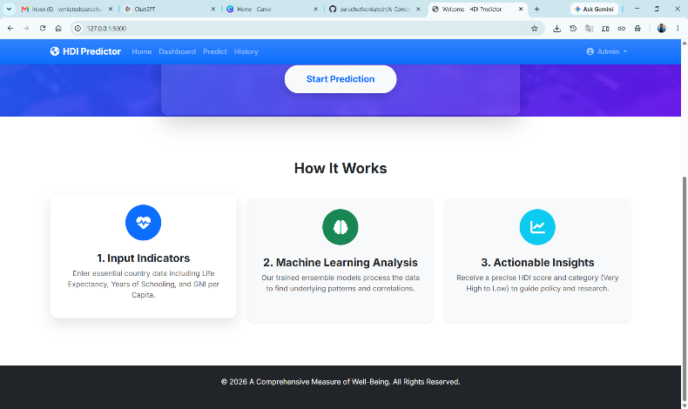
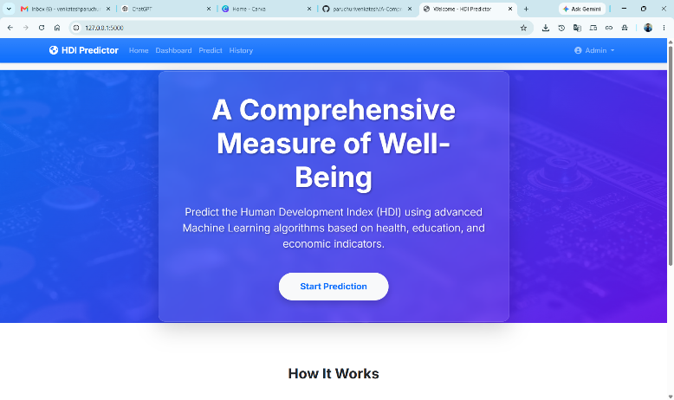

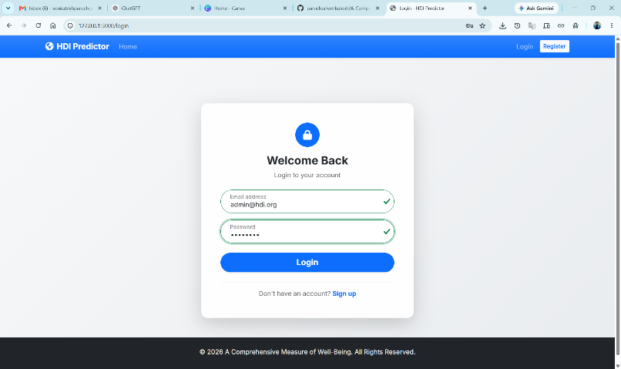
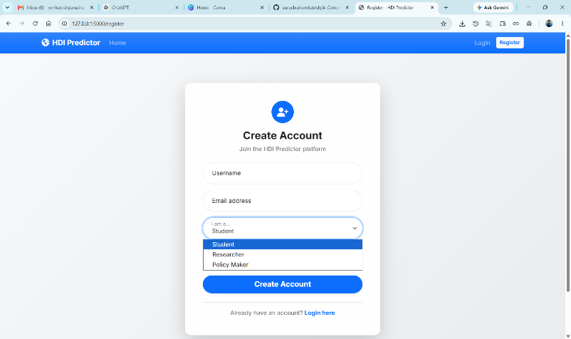

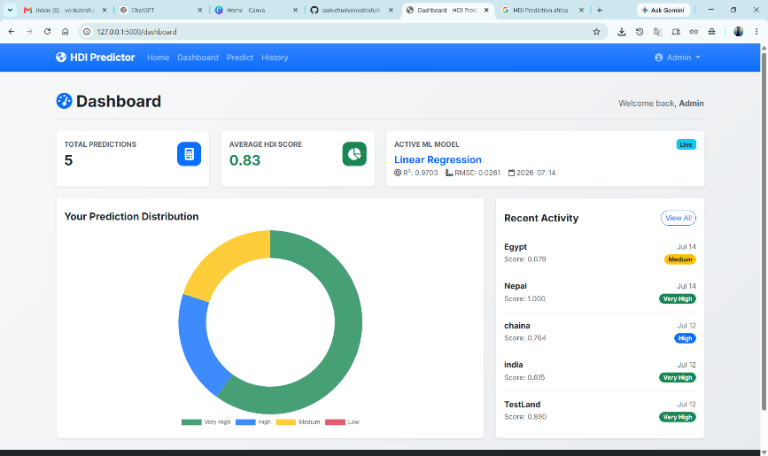
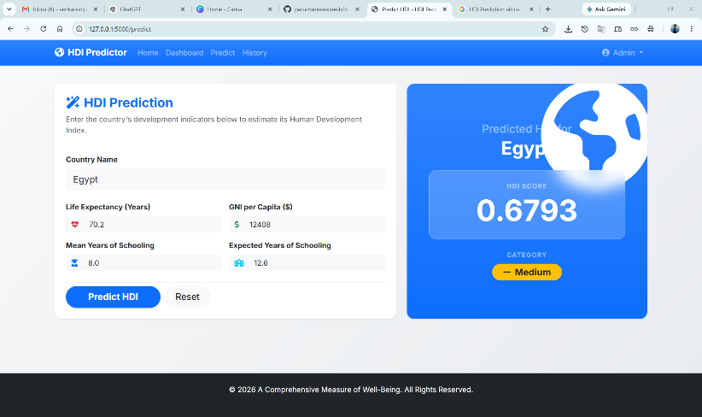

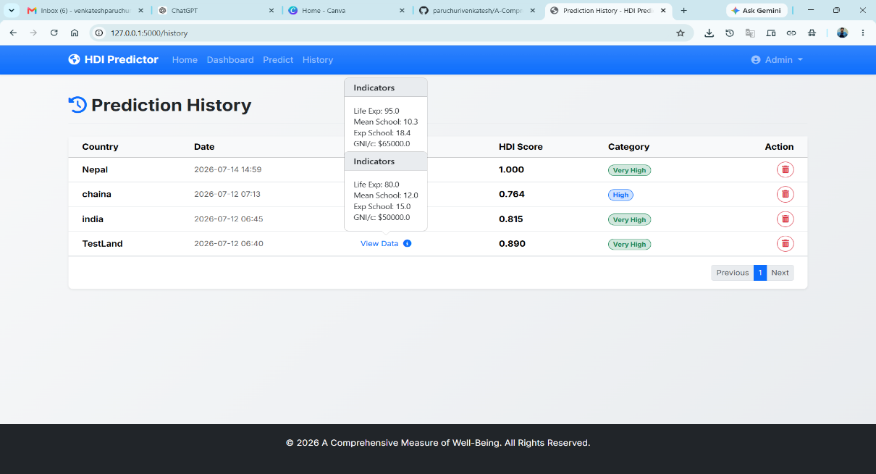

Security Features
Authentication: Flask-Login, password hashing, session management
Input Validation: Client-side and server-side checks
Database Security: SQLAlchemy ORM, parameterized queries
Password Security: Werkzeug hashing, salted storage

Advantages
- Instant HDI predictions
- 93.93% accuracy
- Real-time analytics
- Intuitive interface
- Scalable and reusable
- Educational and cost-effective
- Analytical insights

Business & Global Applications
- Government Planning
- UNDP Research
- NGO Analysis
- Academic Research
- Economic Planning
- Healthcare and Education Analysis
- Financial Institutions
- Policy Simulation

Future Enhancements
- Deep Learning Models (LSTM, XGBoost)
- Explainable AI (SHAP)
- Country Comparison Dashboard
- Interactive World Map

- Live UN Data Integration
- Cloud Deployment (AWS/Azure)
- Docker Containerization
- REST API
- PDF/Excel Reports
- AI Recommendation Engine
- Multi-Language Support
- Mobile Application

Results & Achievements

Technical Achievements:
- High accuracy (R² = 0.9393)
- Responsive interface
- Interactive analytics
- Real-time prediction
- History management

Impact:
- Demonstrates end-to-end ML deployment
- Practical solution for development assessment
- Portfolio and academic ready

Conclusion
The HDI Prediction System integrates Machine Learning and Full-Stack Web Development to create a practical solution for socio-economic development assessment.
It achieves high accuracy, secure authentication, interactive analytics, and robust data management.
The project demonstrates technical excellence in ML deployment, web architecture, and UI/UX design, offering real-world value for researchers, governments, and organizations.
Future enhancements will expand its analytical depth and global applicability.

Project Authors
Paruchuri Venkatesh – Full-Stack Developer, ML Engineer, Project Lead
Rokkam Guna Sekhar – Backend Developer, Database Architect

GitHub Repository:
https://github.com/paruchurivenkatesh/A-Comprehensive-Measure-of-Well-Being

References & Resources
Programming: Python, Flask, Bootstrap
ML Libraries: Scikit-Learn, Pandas, NumPy, Matplotlib

Database: SQLite, SQLAlchemy
Authentication: Flask-Login
HDI Resources: UNDP Reports, World Bank Data, UN Statistics
Design Inspiration: Microsoft Azure, Google AI, Material Design

© 2026 A Comprehensive Measure of Well-Being (HDI Prediction System). All Rights Reserved.

